# bKash Checkout: UI update 2020

## Page 1: Account number entry

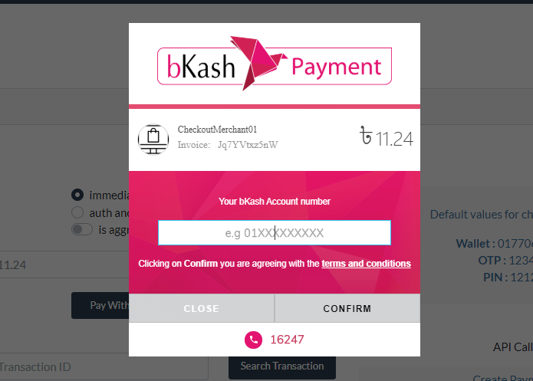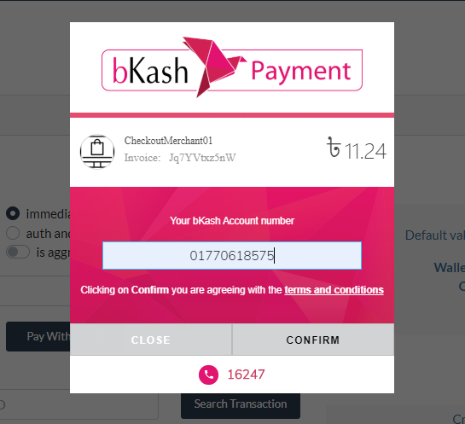

Notes:

"By clicking on Confirm, you are agreeing to the terms & conditions"

## Page 2: OTP entry

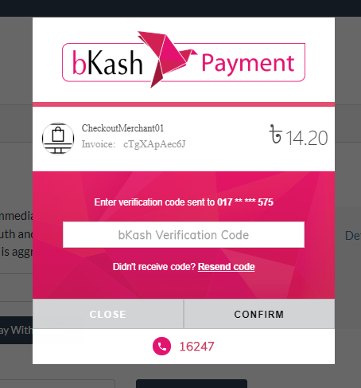

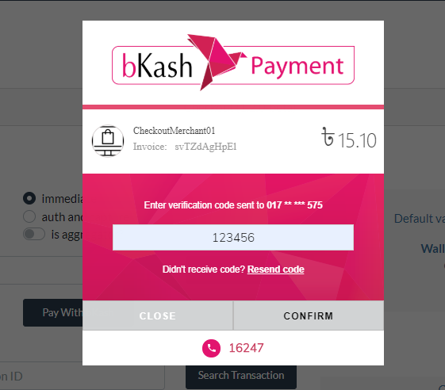

## Page 3: PIN entry

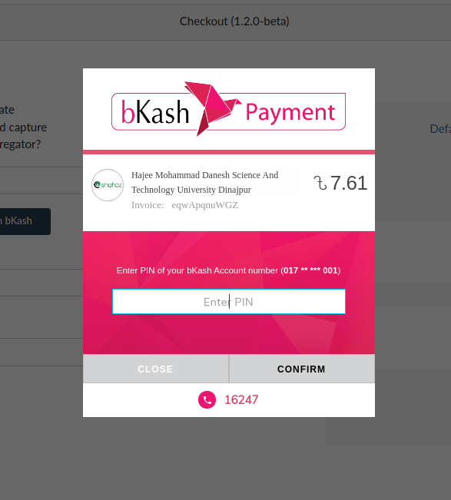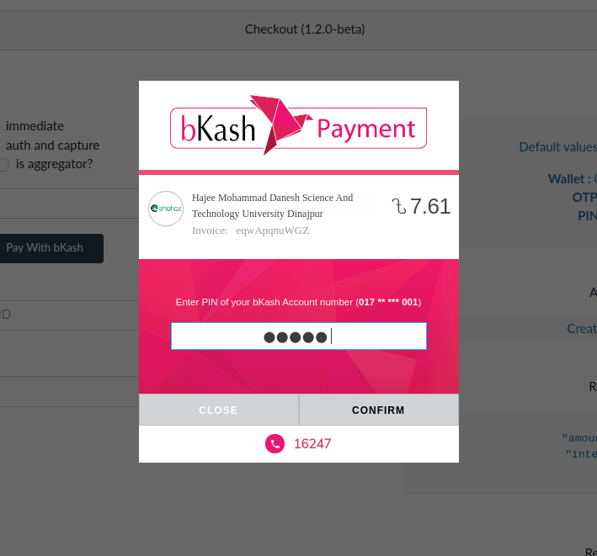

Note:

Page size seemed to change from the other pages. Please make it the same size.

## Other pages

Cancel confirmation page, when CLOSE is clicked

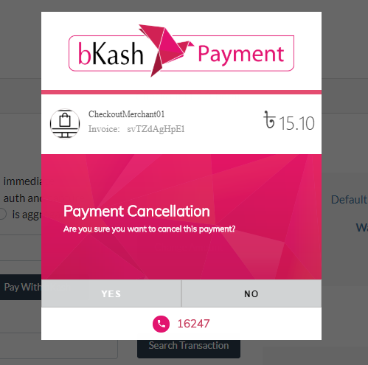

Processing graphics on the CONFIRM button of Page 1, 2 and 3.

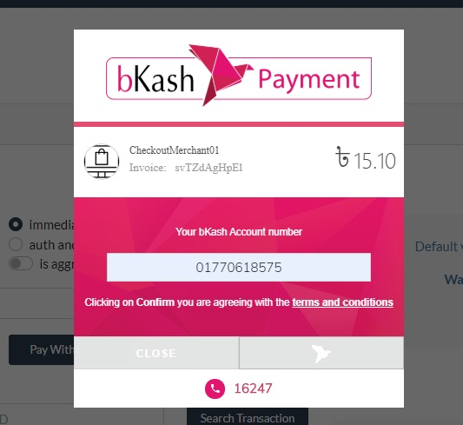

Note:

The Confirm button bird GIF will be updated with another GIF provided.